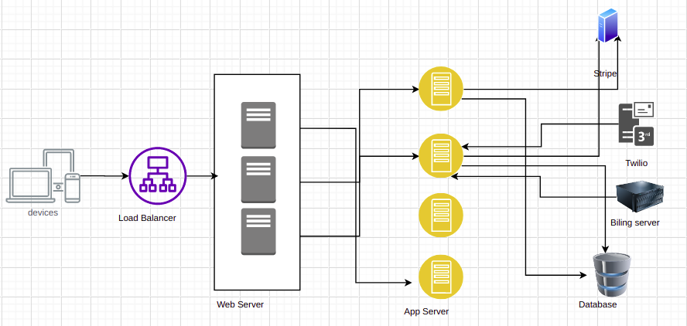

Fig:System Architecture of Dhaka Metro

Given user forecast for the system is:

Daily 100k app login

Daily 80k booking

Daily 50k purchase

Daily 25k journey complete

So the total number of requests will be approximately 235k.

Per minute request will be roughly 163.

Only a web server and app server with one db won’t be able to handle this much query. Having said that the system already has:

1. 2 Load Balancers
2. 2 Web servers
3. 4 Application Servers
4. 2 Billing Servers
5. 2 DB Server

With this configuration, that number of requests per minute can be handled quite easily.

Our new requirement demands the current location of trains.Let's check if this is a heavy-write operation or not.

We can calculate total number of writes per day as:

Assuming there are 2 trains in each route. Total number of trains will be 8.Location is calculated in each 12 seconds.

so 8\*5\*60\*24=56700 number of writes each day.This is not a big number with the current configuration.